We’re scraping the APHC database - <https://aphc.co.uk/find-an-aphc-member/>



Category – Licensed Membership

Postcodes – see end for list.

Other fields not needed

For each postcode, we should get 30 results.

On each result, we need to go down a level using “view details”.

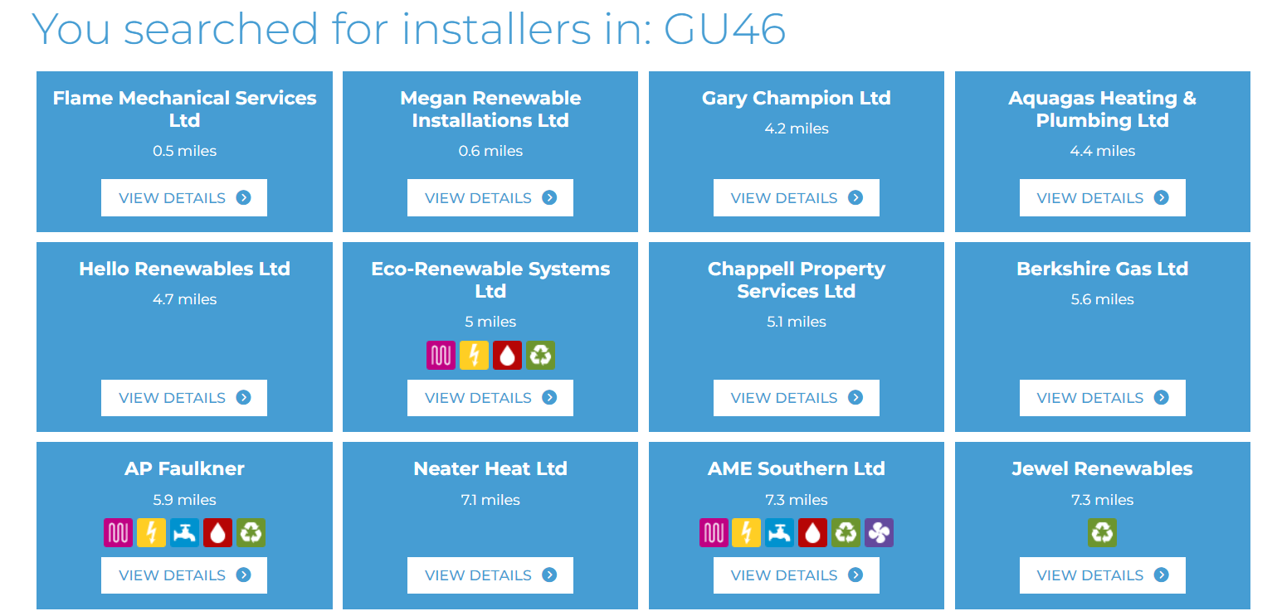

On each individual record we then need to capture:

* The business name
* Contact info (email, phone, address)
* Some of them will have Google reviews – we ideally need the star rating and the number of reviews
* Under “business activities”, all the services that this business offers.

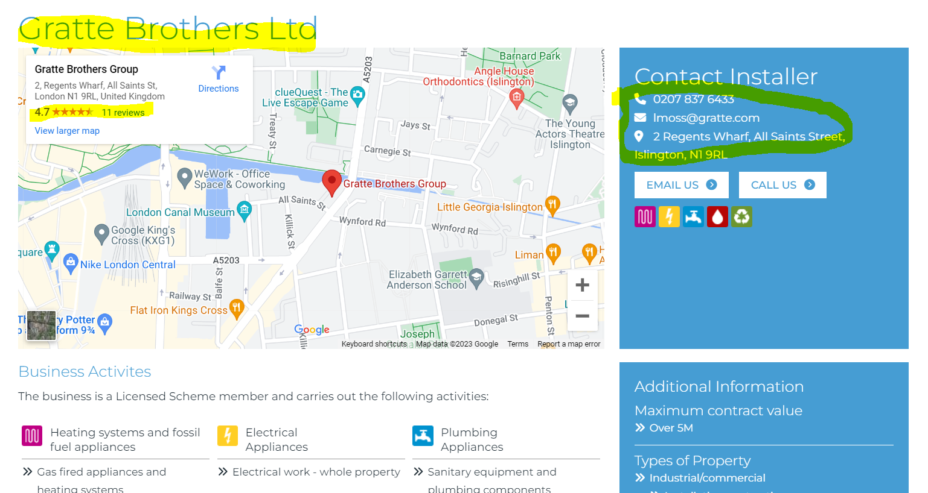

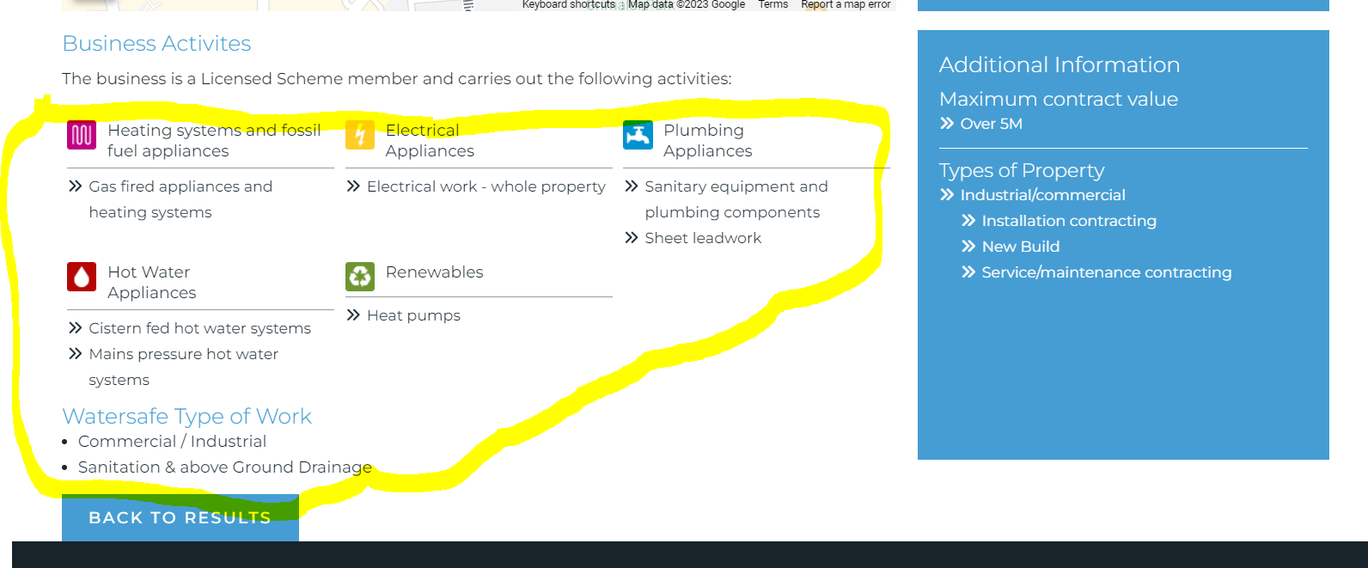

Postcodes to run:   
  
AL2  
BR1  
BR2  
BR3  
BR4  
BR5  
BR6  
BR7  
BR8  
CM13  
CM14  
CM16  
CR0  
CR2  
CR3  
CR4  
CR5  
CR6  
CR7  
CR8  
DA1  
DA2  
DA5  
DA6  
DA7  
DA8  
DA14  
DA15  
DA16  
DA17  
DA18  
E1  
E2  
E3  
E4  
E5  
E6  
E7  
E8  
E9  
E10  
E11  
E12  
E13  
E14  
E15  
E16  
E17  
E18  
E1W  
EC1  
EC2  
EC3  
EC4  
EN1  
EN2  
EN3  
EN4  
EN5  
EN6  
EN7  
EN8  
EN9  
HA0  
HA1  
HA2  
HA3  
HA4  
HA5  
HA6  
HA7  
HA8  
HA9  
IG1  
IG2  
IG3  
IG4  
IG5  
IG6  
IG7  
IG8  
IG9  
IG10  
IG11  
KT1  
KT2  
KT3  
KT4  
KT5  
KT6  
KT7  
KT8  
KT9  
KT10  
KT11  
KT12  
KT13  
KT14  
KT15  
KT16  
KT17  
KT18  
KT19  
KT20  
KT21  
KT22  
N1  
N2  
N3  
N4  
N5  
N6  
N7  
N8  
N9  
N10  
N11  
N12  
N13  
N14  
N15  
N16  
N17  
N18  
N19  
N20  
N21  
N22  
NW1  
NW2  
NW3  
NW4  
NW5  
NW6  
NW7  
NW8  
NW9  
NW10  
NW11  
RH1  
RH2  
RH8  
RH9  
RM1  
RM2  
RM3  
RM4  
RM5  
RM6  
RM7  
RM8  
RM9  
RM10  
RM11  
RM12  
RM13  
RM14  
RM15  
RM19  
RM20  
SE1  
SE2  
SE3  
SE4  
SE5  
SE6  
SE7  
SE8  
SE9  
SE10  
SE11  
SE12  
SE13  
SE14  
SE15  
SE16  
SE17  
SE18  
SE19  
SE20  
SE21  
SE22  
SE23  
SE24  
SE25  
SE26  
SE27  
SE28  
SL0  
SL9  
SM1  
SM2  
SM3  
SM4  
SM5  
SM6  
SM7  
SW1  
SW2  
SW3  
SW4  
SW5  
SW6  
SW7  
SW8  
SW9  
SW10  
SW11  
SW12  
SW13  
SW14  
SW15  
SW16  
SW17  
SW18  
SW19  
SW20  
TN14  
TN16  
TW1  
TW2  
TW3  
TW4  
TW5  
TW6  
TW7  
TW8  
TW9  
TW10  
TW11  
TW12  
TW13  
TW14  
TW15  
TW16  
TW17  
TW18  
TW19  
TW20  
UB1  
UB2  
UB3  
UB4  
UB5  
UB6  
UB7  
UB8  
UB9  
UB10  
UB11  
W1  
W2  
W3  
W4  
W5  
W6  
W7  
W8  
W9  
W10  
W11  
W12  
W13  
W14  
WC1  
WC2  
WD2  
WD3  
WD4  
WD5  
WD6  
WD7  
WD17  
WD18  
WD19  
WD23  
WD24  
WD25